Project Design Phase-II
Data Flow Diagram & User Stories
Date | 17 September 2026
Team ID | Individual project
Project Name | Software Installation Request Automation
Maximum Marks | 4 Marks
Data Flow Diagrams:
The Level 0 DFD illustrates the flow of issue management data across the ServiceNow platform. Information flows from the Employee through the Service Portal Record Producer, where it undergoes real-time client validation. Validated data passes to backend Business Rules and Data Policies, which write the record to the Employee Issue Custom Table, assign ticket priority, and route the record to the target Support / Assignment Group. As support agents resolve the issue, updated status data flows back to the custom store and displays on the employee's portal dashboard.

Simplified DFD

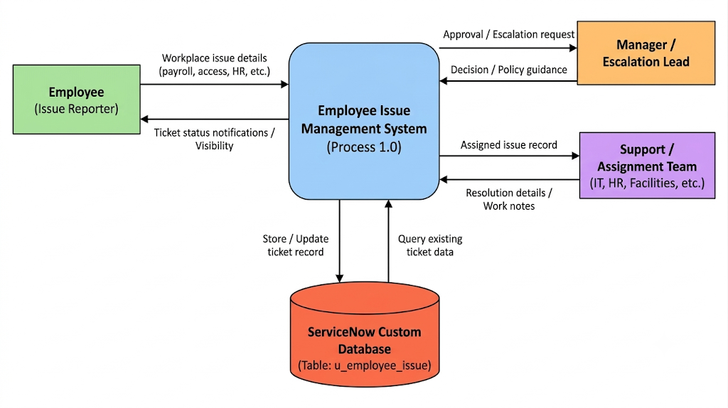

DFD Explanation: ServiceNow Employee Issue Management
The Employee (Issue Reporter) is the primary external entity that initiates the process by submitting a workplace issue (payroll, access, infrastructure, or HR policy) through a custom Record Producer on the Service Portal. The submission automatically generates a structured record in the custom Employee Issue table (u_employee_issue), which serves as the central tracking object throughout the issue lifecycle.
The ServiceNow application processes form inputs through client-side validations (Client Scripts and UI Policies) and server-side logic (Business Rules and Data Policies) to evaluate issue categorization, field dependencies, and priority. For sensitive issues or specific access requests, the workflow routes an approval or escalation request to the designated Manager / Approver. Once approval is confirmed (or automatically for standard issues), Business Rules calculate the priority level and route the ticket to the appropriate Support / Assignment Team (IT, HR, Payroll, or Facilities).
The assigned Support / Assignment Team processes the issue using the generated record. The workflow tracks work notes, activity logs, and state transitions in real time, maintaining an open lifecycle until the support agent enters final resolution details and closes the ticket. If an approval or escalation request is rejected, the workflow updates the ticket state to rejected/closed and halts further assignment to support groups.

User Stories
The following user stories define the main interactions required for the ServiceNow Employee Issue Management solution. Each story is written from the perspective of the user who interacts with or supports the issue reporting and resolution process. The acceptance criteria describe the expected outcome, while priority and release indicate the planned importance and delivery grouping.
USN-1 (Employee Intake): As an employee, I can submit workplace issues via the Service Portal Record Producer to receive an official tracking number in the custom u_employee_issue table.
USN-2 (Employee Tracking): As an employee, I can track my ticket status in real time via the Service Portal dashboard to see assignment and fulfillment progress.
USN-3 (Outcome Notification): As an employee, I can receive automated alerts for approvals, escalations, or ticket resolutions.
USN-4 (Manager Approval): As a manager, I can review, approve, or reject high-priority or sensitive access requests.
USN-5 (Auto-Routing): As a support agent (IT, HR, Payroll, Facilities), I can receive tickets automatically prioritized and routed by backend Business Rules.
USN-6 (Fulfillment & Closure): As a support agent, I can log activity notes and mark the ticket as resolved upon task completion.
USN-7 (System Maintenance): As a ServiceNow Admin, I can configure and update Record Producers, UI/Data Policies, and assignment rules.
USN-8 (Troubleshooting): As a ServiceNow Admin, I can inspect audit trails and script execution logs to resolve processing errors.

User / Process Flow:
The following flow provides a simplified view of how the user interacts with the ServiceNow solution. It complements the DFD by showing the sequence of actions from request submission through approval and fulfillment.

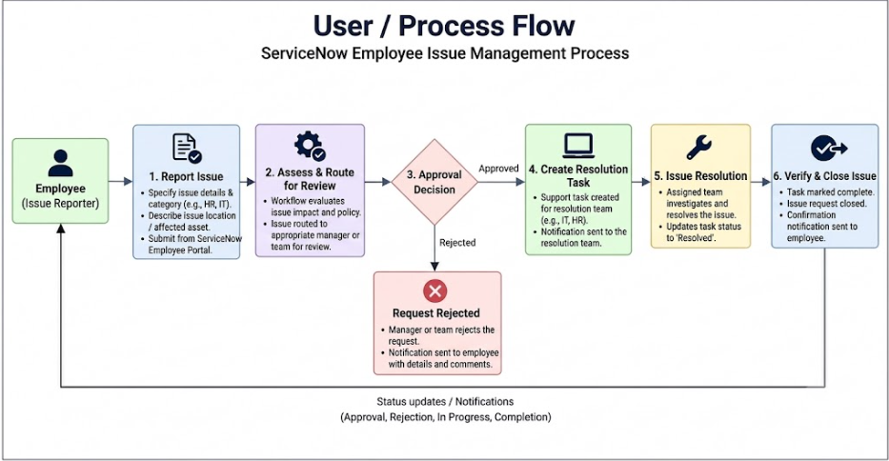
Acceptance Criteria Summary:
Portal Intake & Record Creation: An employee can submit a workplace issue (payroll, access, HR, infrastructure) through the Service Portal Record Producer.
Custom Table Context: A custom Employee Issue record (u_employee_issue) is automatically generated and serves as the primary context for the automated issue management workflow.
Manager Approval / Escalation: An approval request is generated for the designated manager when triggered by ticket criteria (e.g., sensitive access or policy escalation).
Conditional Support Routing: If the request is approved (or for standard issues requiring no approval), backend Business Rules calculate priority and route the record directly to the appropriate Support/Assignment Team (IT, HR, Payroll, Facilities).
Rejection Handling: If the approval is rejected, the approval condition evaluates to false, halting support team assignment and updating the record state to Rejected.
Fulfillment Management: The issue record remains actively assigned in the support team queue until the agent logs work notes and marks the ticket as Resolved.
Execution Audit & Diagnostics: Flow execution details and rule evaluations can be reviewed in Flow Designer / Workflow Studio and System Logs to verify each action's state.

